The 13th ITU TELECOM WORLD, Bangkok 19-22 November, 2013

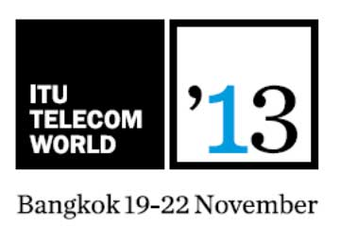

The 13th ITU TELECOM WORLD took place during 19-22 November, 2013 in Bangkok, Thailand.
The ITU Telecom World is looking for the next generation of social technopreneurs! ITU Telecom World 2013 is the platform for high-level debate, knowledge-sharing and networking for the global ICT community - essential to drive industry success and address critical world socio-economic challenges. It is the one conversation that matters, with the people that matter, with the power to make a real difference in the world.
The ITU Telecom World is looking for young entrepreneurs between 18 and 26 with an inspirational ICT – based solution that can really make an impact on the world and improve people’s lives. It doesn’t matter if your idea is a start-up already up and running but in need of funding to implement the next stage and bring it to scale or a concept worked out on paper but in need of support to make it real. They are just looking for innovative solutions to some important developmental challenges.

