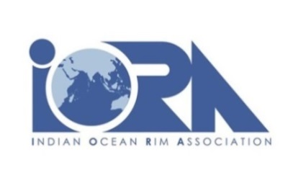 |  | 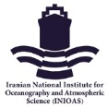

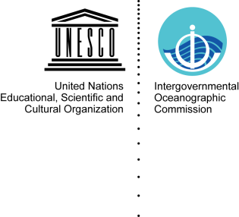 |  | 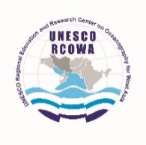 | IOC Regional Committee for the Central Indian Ocean (IOCINDIO)

The First Webinar on the Effects of Climate Change on the Indian Ocean Marine Environment

10 May 2021
11:00 to 15:45 at Tehran time (GMT+4:30)

ONLINE

Programme
The overview of the workshops is based on three themes that cover the climate change over the Indian Ocean and marginal seas:
Workshop 1-Theme 1: Overall view, May 10, 2021
Workshop 2-Theme 2: Oxygenation and acidification, September 2021
Workshop 3-Theme 3: Ecology of marginal seas, December 2021

May 10 2021
Time  (GMT +4:30) | 11:00-11:10 | 11:10 – 11:40 | 11:40- 12:20 | 12:20 -13:00 | 13:00- 13:40 | 13:40 – 14:15 | 14:15 – 14:50 | 14:50 – 15:15 | 15:15 – 15:35 | 15:35 – 15:45
Name of Speaker | Workshop Moderator-  Welcome Speech | Dr. Nafiseh Pegahfar,  Assistant Professor, Department of Atmospheric Sciences, Iranian National Institute for Oceanography and Atmospheric Science | Dr. Juliet Hermes  Assistant Professor, University of Cape Town, South Africa | Dr. Parvin Ghafarian,  Assistant Professor, Head of Department of Atmospheric Sciences, Iranian National Institute for Oceanography and Atmospheric Science | Break | Dr. Roxy Mathew Koll  Scientist, Centre for Climate Change Research, Indian Institute of Tropical Meteorology, Ministry of Earth Sciences, India | Dr. Alizadeh Choobari  Associate Prof., Institute of Geophysics, University of Tehran, Iran | Prof. James Terry  Professor. College of Natural and Health Sciences, Zayed University, Dubai, UAE | Dr. Gholamreza Mohammadpour  Assistant Professor, Department of Atmospheric Sciences, Iranian National Institute for Oceanography and Atmospheric Science | Workshop Moderator
Session Title | Opening | Potential effects of climate change on the extreme events | Modelling, observing  and understanding variability in the Indian Ocean | Variation of atmospheric parameters and related outcomes |  | Understanding and monitoring climate change in the Indian Ocean | Advances and challenges in climate predictions on sub-seasonal to decadal timescales and projections of future climate change | Observed spatio-temporal patterns in tropical cyclone activity in the Arabian Sea | Biogeochemical processes in littoral waters and the influence of anthropogenic activities within time and space | Closing Remarks

