Instruction for entering the webinar room

The webinar link:
https://www.skyroom.online/ch/inioas/iora

For entering the webinar room, use the English version and the icon GUEST.
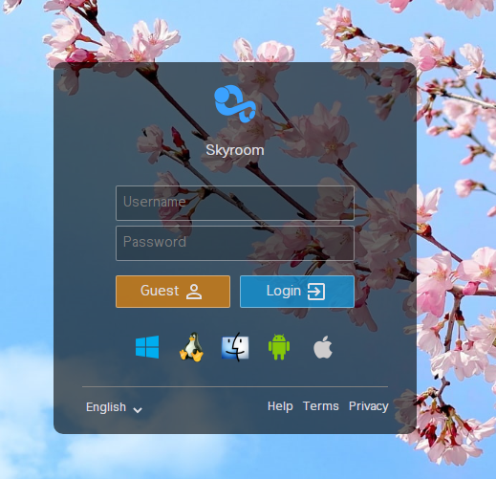

Registration
When you enter, click on the "guest" that will be shown in the list of Users.
Please register your name in the box which will be opened by clicking on "guest". Then your name will be shown on the list.
Please enter your name only in English.

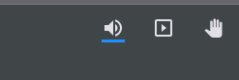
Please use raise hand icon on the top right of the page, if you had any questions and comments or you can write your message in the message box.

